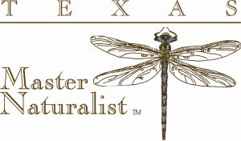
Training Program Starts January 12, 2019
The Texas Master Naturalist (TXMN.org) organization is searching for new members who are passionate about nature and willing to invest their time and talent to preserve and enhance Texas native habitat and the creatures that live there. Through local chapters, they select, train and develop committed volunteers who provide education programs, outreach and various services in support of the management of natural resources throughout Texas. The Lost Pines Master Naturalist Chapter serves Caldwell and Bastrop counties and is taking applications for its 2019 training class right now.
Want to learn more? Check out our website (https://txmn.org/lostpines/)Text or call Nancy at 512 563 3499, or email training@lostpinesmasternaturalist.org.
Space is limited…act now! Become a valued resource in your community, help nature, and have some fun at the same time! https://txmn.org/lostpines/galleries/video-gallery/
http://txmn.org/lostpines/training/basicwithapplicationform

Become a Texas Master Naturalist

Apply Today!

