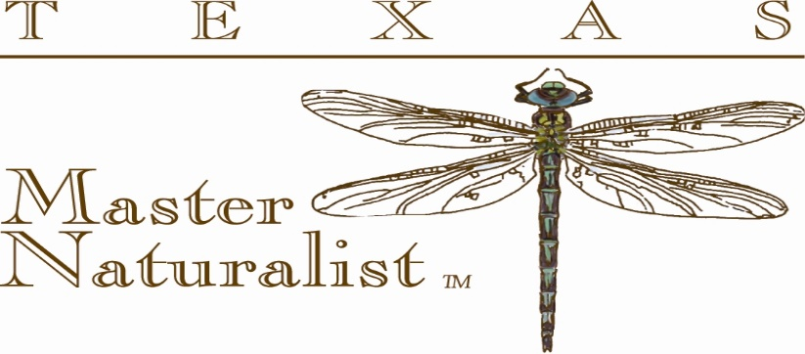
Video/Photo/Audio/Appearance Release Form for the 2019 Texas Master Naturalist Program
The Videographer\Photographer for the Lost Pines Master Naturalist Chapter may be filming\photographing the chapter events for the 2019 Texas Master Naturalist Program. This media archive is used by the Lost Pines Master Naturalist Program to offer students who miss up to 2 classes during the curriculum, an opportunity to make up class time and obtain credit for completion. This Video/Photo/Audio/Appearance Release form is for the entire duration of the 2019 Texas Master Naturalist Program which will begin Jan 12, 2019 to June 8, 2019. Any participant (i.e. Instructor, Presenter, Teacher, Biologist, Speaker, Demonstrator, Texas Master Naturalist member, Volunteer or a new Lost Pines Master Naturalist student) involved in this program, it is recommended to sign this Video/Photo/Audio/Appearance Release form.
Print Name of Participant:
Email address:
Phone #:
I hereby grant the sponsors and co-sponsors participating in the current program the unconditional power, right, privilege & permission to make, record, produce, edit, modify, use the name, voice and photographic likeness of myself in connection with any of the audio\visual production, video recording, photographs, articles or press releases. This would be used for educational outreach postings on websites such as Lost Pines Master Naturalist, Bastrop County Audubon, YouTube, Facebook, Twitter, Texas Master Naturalist Program, Texas Parks and Wildlife and Texas A&M AgriLife Extension Service or other educational outreach websites. Participants also understands that there is no compensation for appearance or participation in the recorded production.
Please visit www.txmn.org/lostpines/galleries/video-gallery for archived short films on our chapter.
Participant typed or signed Signature:
Date:
I am 18 years of age or older and have read this release before signing/typing below, fully understanding the contents, meaning, and impact of this release

