Nancy Rabensburg
Training Director
Lost Pines Master Naturalist
519 Tahitian Dr.
Bastrop, TX 78602
November 1, 2021

Dear Texas Master Naturalist Program Applicant:
I would like to invite you to join an exciting volunteer program for the Bastrop and Caldwell County area—the Lost Pines Chapter of Texas Master Naturalist™ (LPMN) 2022 Basic Training Course. The mission of the Texas Master Naturalist™ (TMN) program is to develop a corps of well-informed volunteers to provide education, outreach, and service dedicated toward the beneficial management of natural resources and natural areas within our communities.
The LPMN Basic Training Course provides participants with essential information and strategies to restore and conserve our indigenous species and habitats. Throughout the training classes, experts will cover topics about our natural resources and lead hands-on field trips to local ecosystems. After graduation, we are all about volunteering in the local community. Texas Master Naturalist™ trainees will have a wide variety of approved local projects to choose from. Projects may include habitat restoration and maintenance, bio-surveys, state park programs, school curriculum development, water and other monitoring activities, citizen science projects, interpretive or educational presentations, or projects of your own design.
Lost Pines Chapter of Texas Master Naturalist™ has been approved as a Continuing Professional Education (CPE) Provider for Texas by the Texas Education Agency.
There is a difference between graduating and becoming certified. To become a certified Texas Master Naturalist™ of the Lost Pines Chapter, trainees must fulfill the following requirements:
  - Students must complete a minimum of 40 hours of training. A maximum of two missed classes can be made up by viewing and summarizing a video of the class by December 31, 2022. We recognize that unforeseen events and emergencies can occur over the 5-month training period and having the opportunity to make up missed classes ensures you can complete the entire training program.
- 40 hours minimum of volunteer service on approved projects by December 31, 2022 (we encourage trainees to begin volunteer service simultaneously with the beginning of training classes, if possible).
- 8 hours of advanced training in approved classes of your choice (outside the Basic Training offered) by December 31, 2022.
After basic training is completed and initial certification is earned, chapter members must complete the following annually to maintain their certification as a Texas Master Naturalist:
- 40 hours of volunteer service on approved projects
- 8 hours of advanced training in approved classes
- Pay annual dues
We encourage you to continue to be involved in the program and attend Chapter activities even if you don’t meet the certification requirements. A chapter member in “good standing” is defined as current in annual dues and in compliance with Master Naturalist Code of Ethics and Standards of Conduct.
Training classes will be held from 6:00 PM to 9:00 PM, on Monday evenings (approximately 3 per month), plus 9 Saturdays, some being field trips, beginning January 15, 2022, with our graduation celebration on June 4, 2022.
The fee for this training is $130.00, which covers the cost of the TMN Training Manual, class materials and handouts, venue rental and fees, 2022-chapter dues and graduation expenses.
In 2022, everyone is responsible for their own food and drink.
TMN policy, and the policy of TMN’s major sponsors (Texas AgriLife Extension Service and Texas Parks and Wildlife) require that volunteers undergo a background screening at least every three years. TPWD will complete the background check after an applicant provides the necessary information and is accepted into the training program.
Also attached is the class schedule for 2022. Please note that class dates and locations are subject to change based on unforeseen circumstances, such as speaker availability, adverse weather conditions, or other scheduling conflicts.
The application deadline is December 15, 2021. Please complete the enclosed Application for Basic Training Program and forward, along with a check made payable to LPMN for $130.00, to:
Nancy Rabensburg 519 Tahitian Dr, Bastrop, TX 78602, or email: mailto:training@lostpinesmasternaturalist.org. Note: payment of the class fee may be made on our website via PayPal at the following link, http://txmn.org/lostpines/training/basic-training-with-application-form/.
To assure that all interested individuals have an opportunity to get into the class, please carefully consider your schedule and the time commitment required to complete the training program. Class size is limited to 25 participants to provide a quality experience for each student.
Thank you for your interest in the Texas Master NaturalistTM program. We look forward to your participation in this educational and beneficial volunteer program. If you have any questions, please contact Nancy Rabensburg, Training Director, mailto:training@lostpinesmasternaturalist.org.
Attachments/Enclosures: 2022 Application
Link to Background Check ( in yellow highlight)
2022 Class Schedule (tentative)

Nancy Rabensburg
Training Director
Lost Pines Master Naturalist
519 Tahitian Dr.
Bastrop, TX 78602
APPLICATION FOR BASIC TRAINING PROGRAM

Save a copy of this application to your computer before completing. It will not save to the website. You can email your completed form to:
mailto:training@lostpinesmasternaturalist.org Or, print and mail to the address above.
Please type or print clearly.
___________________________________________ ______________________________
Name (please print full name, for TPWD) Prefer to be called
___________________________________________ ______________________________
Mailing Address: Street / Apt / P O Box DOB (needed for TPWD background check)
_________________________________________________________________________________________
City County State ZIP
Home phone: ______________________________ Cell phone ______________________________

Please check your preference
Email address: _____________________________________________________________________________
Emergency Contact: _________________________________________________________________________
Name Relationship Phone
Place of Employment:
__________________________________________________________________________________________
What is/was your profession? __________________________________________________________________________________________
Are you employed ____ full time ____ part-time ____ retired
How did you learn about TxMN? ______________________________________________________________
Are you a registered volunteer with TPWD? ______
- I am 18 years of age, or older.
- I will be available for classes conducted from 6 pm – 9 pm on Mondays, plus 10 Saturday sessions
beginning on Saturday, January 15, 2022, and continuing through Saturday, June 4, 2022.
- I understand that to qualify for certification, by December 31, 2022, I am required to (a) attend a minimum of 40 hours of Basic Training; (b) attend an additional 8 hours of advanced training of my choice outside Basic Training; and (c) complete 40 hours of approved volunteer service.
__________________________________________________________ _________________________
Signature Date
Goals of the Texas Master NaturalistTM program
- To provide service to the community through public educational programs that promote understanding and conservation of our natural resources, foster an appreciation of the diversity of our plant and animal species and promote stewardship and conservation of our natural environment; and
- To provide opportunities for Texas Master NaturalistTM to use and expand their knowledge and skills in ways that will benefit and interest the volunteers and promote the Texas Master NaturalistTM program.
Volunteer Pledge:
I understand that in exchange for the training made possible through the Texas Master NaturalistTM program,
I will volunteer at least forty (40) hours of my time to the Texas Master NaturalistTM program, and I will complete eight (8) hours of advanced training, both to be completed by December 31, 2022. I understand that I will become a Certified Texas Master NaturalistTM when I complete both the training and volunteer work.

Signature Date
Return your application documents and payment no later than December 15, 2021.
Enrollment is limited.
Registration Fee of $130.00 is due by December 15, 2021 ($150.00 is due if paid after December 15, 2021). A husband and wife (or significant other) will be offered a discount of $35.00 if they elect to receive only ONE training manual to share. A fee of $35.00 will be withheld from the training fee refund if enrollment is cancelled after January 15, 2022.
Educational programs of the Texas A&M AgriLife Extension Service are open to all people without regard to race, color, sex, religion, disability, age (must be 18 years of age or older), or national origin. Individuals who require an auxiliary aid, service or accommodation in order to participate in Extension sponsored programs are encouraged to contact the County Extension office to determine how reasonable accommodations can-be-made.

Next Steps… Register as a volunteer with TPWD. This will initiate the Background Check necessary to take the training and volunteer in our parks.
https://tpwd.samaritan.com/recruiter/index.php?recruiterID=1450&class=VolunteerRegistration#

Your areas of VOLUNTEER INTEREST: Rate your interest as HIGH, MEDIUM or LOW—If you have experience or training in this area, please check the experience box.
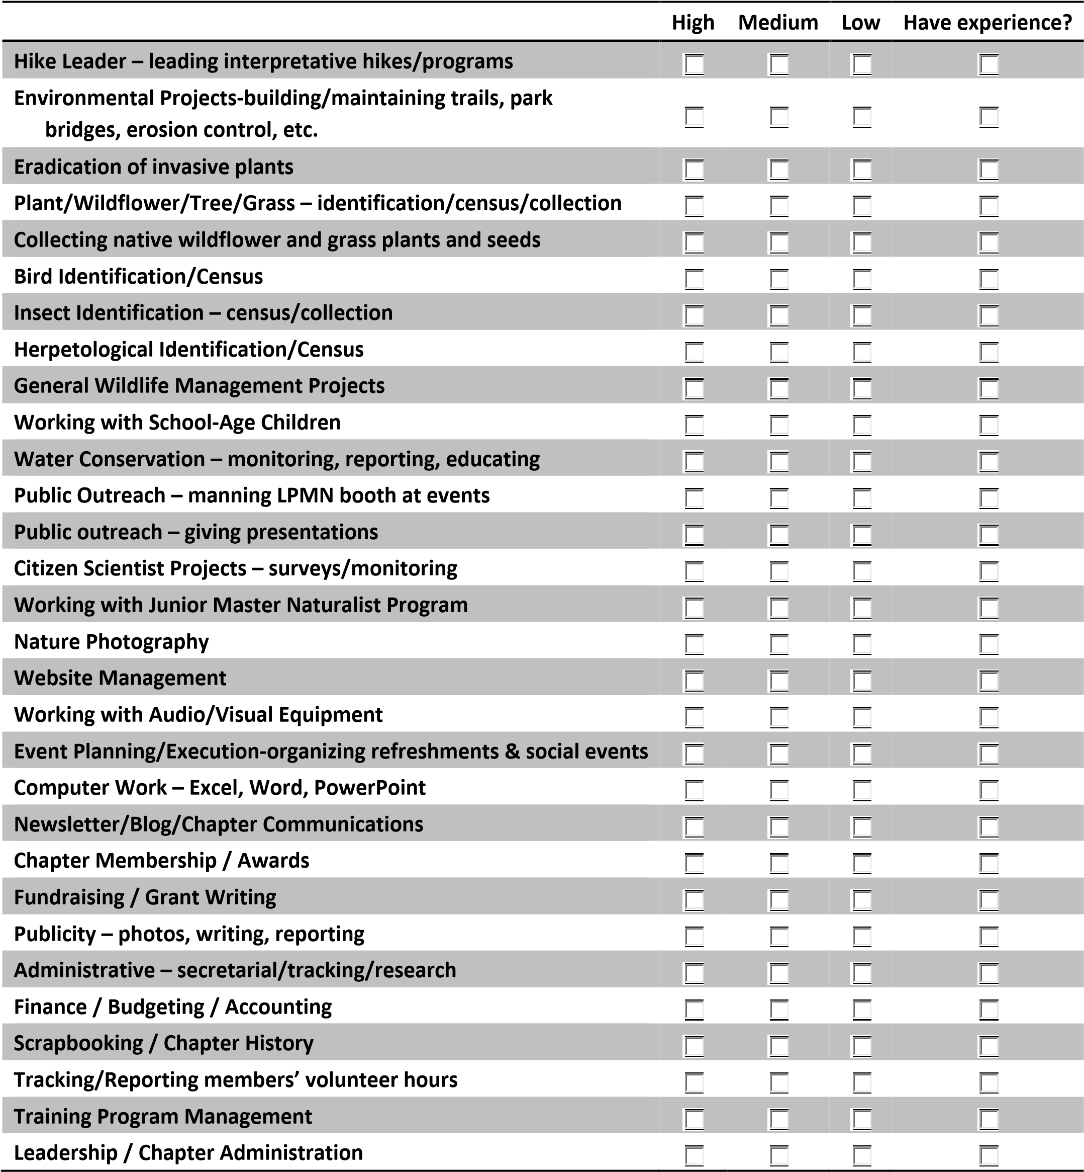
Is there anything you'd like to add that we haven't asked about? _________________________________________________
_____________________________________________________________________________________________________
_____________________________________________________________________________________________________

