
Chad Huckabee, STMN
Revised February, 2026
Common Fish Family Descriptions for the Coastal Bend
This document is intended to aid the Master Naturalist to fish families likely to be encountered in routine observation of the Coastal Bend marine, estuarine and freshwater habitats.
Terms:
Adipose fins are soft tissue projections near the caudal fin.
Barbels are long, soft sensors usually around the mouth.
Cirri are hairlike projections over eyes, nostrils or mouth parts.
Ganoid scales are very hard scales on some of the most ancient fish that remain extant.
Lateral line is a sense organ along the side of many fish.
Rays are segmented highly flexible structures bearing membrane between rays.
Spines are solid (usually hard and sharp) projections on fish fins.

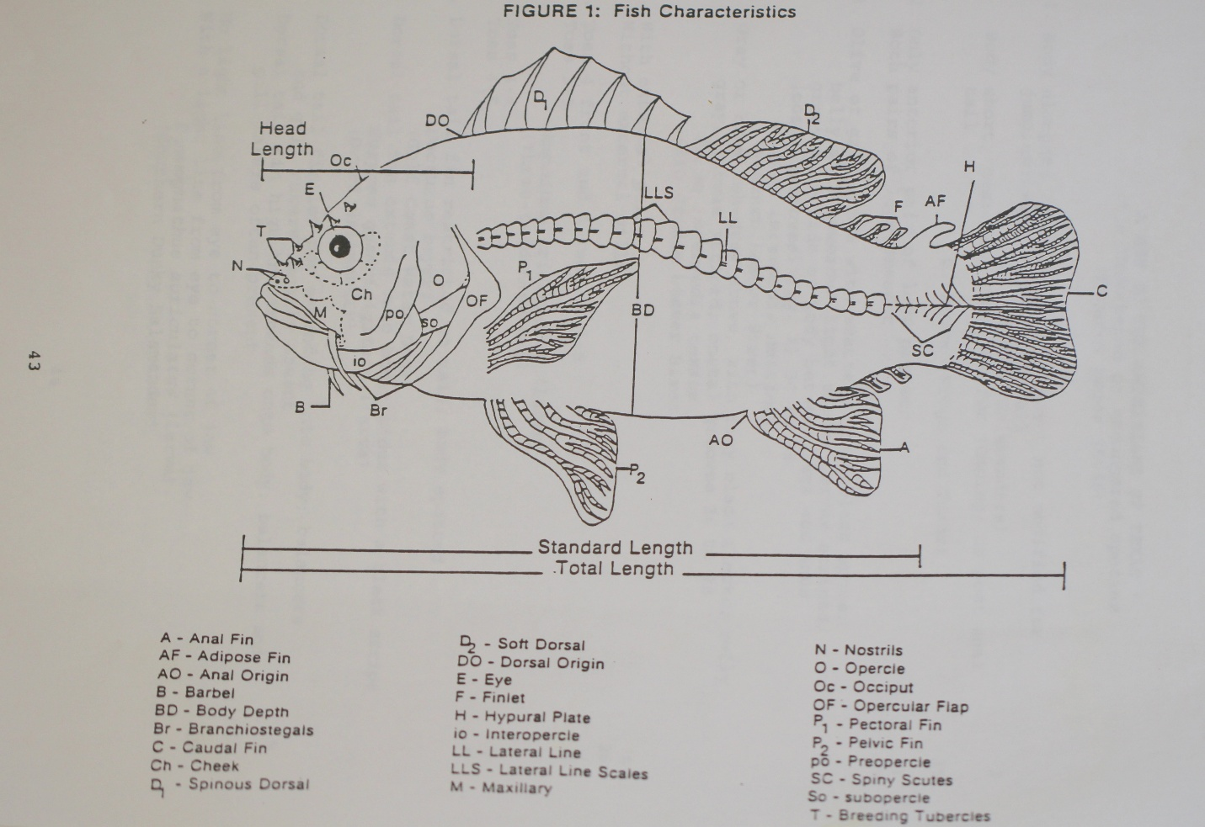

Common Family Name | Scientific Family Name | # | Family Characteristics
Anchovies | Engraulidae | 2 | Small fish to 10 cm long with inferior mouth, overhung by a large, usually protruding snout. Maxillary reaching well beyond eye, sometimes to edge of operculum. Silvery, lateral band present.
Angelfishes | Pomacanthidae | 1 | Lateral view of body is rounded, fishes with small scales. Mouth small, terminal, with bristle-like teeth. Strong spine from lower angle of opercle. Dorsal and anal fins usually prolonged into filaments. Very colorful when alive.
Barracudas | Sphyraenidae | 2 | Typical fish form body. Elongate, long-jawed fish with strong teeth. Scales small. Pelvic fins abdominal. Dorsal fins are widely separated, 5 spines 9 rays; anal fin 1 spine, 8 soft rays.
Bluefish | Pomatomidae | 1 | Body laterally compressed with medium dorsoventral depth. Mouth large, oblique, with large teeth. Preopercle serrated. Lower jaw projecting. First dorsal fin of low and weak spines. Two spines preceding anal fin. Caudal fin forked. Greenish blue with silvery reflections.
Box Fishes | Ostraciidae | 2 | Body truncate and not streamlined for rapid swimming. Scales fused into a rigid armor covering enclosing the entire trunk except for the eyes, mouth, gill slits, fins, and caudal peduncle. Dorsal view roughly triangular with ventrolateral keels ending in strong spines. Dorsal, anal, and caudal rays 10. Teeth in a single row in each jaw; conical to incisor-like in shape
Bullhead Catfishes | Ictaluridae | 7 | Body with disproportionally large head. Body naked; head with 4 to 8 barbels; posterior nostril with a barbel; with an adipose fin present.
Butterfish | Stromateidae | 2 | Lateral view rounded silver fishes with the scales so small and embedded that the body appears naked. Spinous dorsal fin and pelvic fins are absent. Anal fin with 3 spines and 36 or more rays.
Butterflyfish | Chaetodontidae | 2 | Body laterally round or rectangular. Mouth small, terminal, with brush-like teeth. Dorsal and anal spines strong. Color is usually silvery with yellow and black pattern.
Carps and Minnows | Cyprinidae | 44 | Typical fish form body, slight lateral compression. Distance from anal origin to caudal base more than 1/2 distance from dorsal origin to caudal base; if not, barbels present or dorsal rays 9.
Cichlids | Cichlidae | 4 | Lateral view perch-like. Fresh water only; lateral line interrupted near dorsal fin termination; caudal fin rounded.

Clingfishes | Gobiesocidae | 1 | Vertical view of head broadly rounded and compressed. Eyes small. Caudal long, rounded. Pelvic fins form a broad “sucker-like” structure.
Clinids | Clinidae | 1 | Typical fish form body laterally. Dorsal and anal fins long; the dorsal spines 15 or more and the rays 12 or less in our species. Pelvic fins reduced to 8 spine and 3 rays or less and inserted in front of the pectorals. Mouth large, terminal. Scales present. Cirri present over eyes and nostrils, at lease in males.
Combtooth Blennies | Blenniidae | 5 | Small fishes which lack scales and have long dorsal fins with more rays than spines. Pelvic fins reduced to 1 spine 2 or 3 rays, the elements usually hard to count, inserted before the pectoral. Mouth small to large, usually subterminal. Cirri sometimes present over eyes and nostrils. Dorsal spines flexible.
Cutlass Fishes | Trichiuridae | 1 | Body greatly compressed and elongated (eel-like). Dorsal and anal fins extend the entire length of the beyond coming to a point terminally. Lower jaw protruding. Teeth large barbed canine projecting anterior. Silvery body: silver easily rubbed off. Caudal fin absent.
Damsel Fishes | Pomacentridae |  | Lateral view oval and body laterally compressed. Small, shiny-scaled fishes with only a single nostril on each side of the head. Dorsal with 12 or 13 spines; 2 anal spines. Lateral line ending under posterior base of dorsal fin. Live specimens are highly colorful.
Drum | Sciaenidae | 16 | This family is highly variable in body form and shape of dorsal fin; anal fin with only 1 or 2 weak spines. Lateral line extending onto the caudal fin. One or more barbels are often present on the lower jaw. Caudal fin never deeply forked, usually truncate or rounded. Lateral view may be oval or elongate; body often with black spots or bars on silver background.
Flounders, Left Eyed | Bothidae | 5 | Small to large flatfish with eyes and color on the left side. Pectoral fin of left side is well developed, often elongate. Preopercle with a free edge not covered by skin and scales. Lateral lines are well developed on left side and usually also on right side. Teeth present in jaws.
Freshwater Eels | Anguillidae | 1 | Large eels with prominently projecting lower jaw. Body covered with small, embedded scales. Caudal fin present.
Freshwater Trout | Salmonidae | 2 | Lateral view of this group is typical fish form (typical fish shape). Fresh water; with more than 50 lateral line scales pelvic origins posterior to dorsal origin.
Frogfishes | Antennariidae | 1 | Mouth large, dorsally inclined. Body oval in cross-section and not much longer than high. An external dorsal fin of separated spines.

Gars | Lepisosteidae | 4 | Mostly fossil group recognized by the distinctive ganoid scale of layered bone. Caudal fin heterocercal. Pelvics abdominal, pectorals low on body. Mouth an extended bony bill. Entire body well armored.
Gobies | Gobiidae | 13 | Generally small to medium sized fishes which lack a lateral line. Pelvics have 1 spine and 5 rays, either connected by a basal membrane or separate. Dorsal fins long or short, continuous or separate, the spines are flexible. Scale present or absent. Caudal fin is rounded or lanceolate. Gobies have fused pelvic fins that form a ventral sucking disk.
Grunts | Haemulidea | 9 | A variable family which is hard to define. Body typical fish form, usually thick or only moderately compressed. Lateral line not extending onto the caudal fin. Three anal spines. Head usually pointed. Twelve or 13 dorsal spines; anal spines 3, soft rays 7-13. Teeth absent on vomer and those in jaws not modified into molars posteriorly or incisors anteriorly.
Halfbeak & Flying Fish | Exocoetidae | 2 | Body typical fish form and elongate with long lower bill extension. No spinous dorsal fin, the soft dorsal located posteriorly. Caudal fin with lower lobe is usually longer than upper. Lower jaw elongated and/or pectoral fin greatly elongated. Lateral line on ventrolateral surface. May be confused with needlefish.
Hammerhead Sharks | Sphyrnidae | 4 | Shark body: Head expanded laterally int a hammer or kidney-shape. Skin has texture of sandpaper. Eyes at end of head extensions.
Herrings | Clupeidae | 8 | Mouth usually terminal or dorsal, the body is usually deep; if mouth is ventral then the snout is not distinctly pointed. Maxillary relatively short, not extending beyond eye in most forms. Usually no silvery lateral band.
Jacks | Carangidae | 13 | A large and variable family, generally recognized by the absence of scales or very small and embedded scales, deeply forked caudal fin, and the presence of two anal spines in front of the anal fin. Spinous dorsal fin short, usually low, sometimes embedded in skin and tissue, as also may be anal spines. Lateral line commonly armored with high, spiny scutes posteriorly; base of caudal fin with skin fold. Body typical fish form to elongate, round-bodied to deeply compressed. Coloration is shiny yellowish, bluish or silvery.

Killifishes | Cyprinodontidae | 28 | Small fish (to 8 cm); typical fish form body. Mouth small, terminal or dorsal. Lateral line absent. Caudal rounded or truncated. Dorsal and anal fins are similar. Male anal fin like that of female. Male breeding color often irredescent on top of head.
Livebearers | Poeciliidae | 10 | Body typical fish form: 3rd anal ray branched (first ray more than ½ length of third ray); less than 8 branched anal rays.
Lizardfishes | Synodontidae | 1 | Cigar-shaped fish with heavy scales, large mouths, prominent adipose fins, pointed mouth and large abdominal pelvic fins.
Mackerels | Scombridae | 3 | Usually, large typical fish form fishes with small scales which are often absent over much of the body or enlarged in the pectoral region. Caudal peduncles are slender, very strong, with 2 lateral keels. Caudal fin large, truncate. Dorsal and anal fins followed by isolated finlets. Mouth large, terminals and man cutting teeth.
Mojarras | Gerreidae | 5 | Silvery fishes with 2 or 3-week anal spines. Caudal fin deeply forked. Head pointed, the mouth small. Premaxillaries extremely protractile, sliding into grooves in the forehead; a naked interorbital area marks the extent of the premaxillaries.
Moray Eels | Muraenidae | 2 | Jaws present; elongated body; eyes on opposite side of head; pectoral and pelvic fins absent.
Mullets | Mugilidae | 3 | Silvery fishes with large scales. Dorsal fins widely separated; 4 spines 5-8 soft rays. Pectoral fin is set high on body. Pelvic fin under posterior part of pectoral; anal fins 3 spines, 8 or 9 soft rays.
Needlefish | Belonidae | 1 | Elongated fish with a single dorsal fin similar to the anal fin in shape and position. Lateral line on ventrolateral surface. Both jaws are elongated into bony beaks with large teeth. Pectoral fin about equal to postorbital part of head. May be confused with halfbeak.
Perches | Percidae | 25 | A serranid-like family based on osteology and not easily separable on external characteristics. Spinous dorsal slightly separate from soft dorsal. Anal spines one or 2 (in some fish they may be soft). Posterior nostril is dorsal to anterior nostril; lateral line does not extend onto caudal fin.
Porcupine Fishes | Diodontidae | 2 | Puffers with 2 or 3 rooted spines and large eyes equal to or longer than the snout length. The teeth are fused into a single dental plate in each jaw, there being no median suture or gap like that found in the family Tetraodontidae.

Porgies |  | Sparidae |  |  | 3 | Teeth modified into low, rounded molars posterior: anterior teeth often incisors. Often small, forwardly directed spine before the dorsal fin, partially buried in the skin. Dorsal spines 11 or 12; anal spine 3. Head usually rounded in profile. No teeth on vomer.
Puffers |  | Tetraodontidae |  |  | 3 | Body moderately elongate, the dorsal and anal fins set far back. Body smooth or with small prickles. Teeth fused into beaks, each with a median division at the front, producing 2 plates in each jaw.
Requiem Sharks) |  | Carcharhinidae |  |  | 7 | Stereo typical shark body; last gill slit located over the pectoral fins; the caudal fin as the lower lobe short, less than ½ the length of the upper lobe; the length of the upper lobe much shorter than the body length, usually less than half the length of the body or 1/3 if the total length; one or more gill slits located over the pectoral fin base.
Sawfishes |  | Pristidae |  |  | 2 | Shark body: snout elongated into a flat, saw-like projection.
Scorpionfishes |  | Scorpaenidae |  |  | 2 | Chunky, thick, round-bodied fishes with large spiny heads and a short anal fin of 3 spines and 5 or six rays. Caudal rounded. Scales small, the lateral line is distinct. Head with many spines.
Sea Basses |  | Serranidae |  |  | 29 | Body with 3 anal spines and dorsal fins usually continuous; upper part of the maxillary is not hidden under the suborbital when the mouth is closed as it is in the snappers; “typical" fish appearance; often highly decorated and colored.
Sea Catfishes |  | Ariidae |  |  | 2 | Nostrils without barbels; one or two pairs of barbels on lower jaw; prominent maxillary barbels. Males of some species mouth brooders.
Sea Chub |  | Kyphosidae |  |  | 1 | Oval, deep-bodied fish with a small terminal mouth with incisor teeth. Caudal fin deeply forked. Dorsal and anal fins low, with heavy basal sheaths of scales and skin. Dark gray with dull stripes on body.
Seahorses & Pipe Fishes |  | Syngnathidae |  |  | 7 | Body and tail covered with encasing circles of bony plating. Pelvic fins are absent, anal fin small or absent. Caudal section of body long, slender. Dorsal fin large, located about over anus.
Searobins |  | Triglidae |  |  | 4 | Typical fish form, but angular head. Generally slender fish, the head bony and with strong spines and ridges. Dorsal fins separate; one anal spine. Pectoral fins divided into a normal upper portion and 2 or 3 free, thickened, unbranched rays. Upper jaw wide, flat, bony.
Silversides | Atherinidae |  | 5 | Small fish with silvery lateral band and a forked caudal fin. A small spinous dorsal fin is present and well separated from the soft dorsal. Anal fin longer than soft dorsal.
Snappers | Lutjanidae |  | 4 | Typical fish form body. “Typical” fishes with 3 anal spines, a forked caudal fin, and usually a notched dorsal fin. A strong canine is usually present in each upper jaw. Maxillary slipping beneath suborbital when the mouth is closed, separating the snappers from the serranids.
Soles | Soleidae |  | 3 | Broadly oval flatfishes with caudal peduncle very short; the eyes and color on the right side; pelvic fin of the right side attached to the anal fin. Dorsal fin begins on snout. Preopercle covered with skin, its edge not free. Mouth small toothless or nearly so. Lateral line straight and well developed. Pectoral fin or eyed side small or absent.
Spade Fishes | Ephippidae |  | 1 | Body rounded, the caudal peduncle short. Body nearly as long as broad. Teeth brush-like, mouth small and terminal. Dorsal 9 spines; 21-23 soft rays; the third spine very elongate in small specimens. Lobes of soft dorsal and anal high in adults silvery, usually with 4 to 6 broad black bands. Young all black, a phase sometimes seen in larger adults specimens as well.
Stargazers | Uranoscopidae |  | 1 | Typical fish form body with large head. Mouth very oblique, dorsal very large; lips generally fringed. Pelvic fin large, strong, and jugular. Eyes dorsal. Top of head bony. Dorsal spine low, few or absent; soft dorsal and anal similar. Plates on top of head can produce electrical charge.
Stingrays | Dasytidae |  | 3 | Flattened body shape. Absent of paired dorsal fins, cephalic area not raised to produce a distinct forehead, and no cephalic fins. Mouth is ventral. Caudal is fin present or absent. Low ridges may be present on the tail, probably equivalent to dorsal and anal fins but greatly reduced in size. Large, barbed spine or sting are usually present. Tail generally long and thin (may be long and stout or short and thin).
Sunfishes | Centrarchidae |  | 19 | Typical fish form body; laterally compressed. Preopercle smooth or slightly serrate; all teeth in both jaws approximately equal in size; freshwater only.
Tarpons | Elopidae |  | 2 | Typical fish form body. Moderate to very large fishes with the mouth large and terminal or dorsal. A gular plant is present.
Temporate Bass | Percichthyidae |  | 3 | Typical fish form body. Longest dorsal and anal rays do not extend to base of caudal fin; opercle ends in a sharp spine or spines; dorsal fins separated, or if narrowly united, 2nd dorsal spine longer than 9th.
Threadfins | Polynemidae |  | 1 | Body compressed, typical fish form. Dorsal fins widely separated, 8 spines, 12 soft anal rays. Anal fin 3 spines, 13 soft rays. Mouth inferior, large overhung by conical, translucent snout. Caudal fin large, deeply forked. Pectoral fin in 2 parts, the upperpart normal, the lower part of 8 long free rays. Silvery, fins dusky.
Toadfishes | Batrachoididae |  | 2 | Body typical fish form with head and mouth are dominate features. First dorsal fin low, with two or three heavy spines almost covered with heavy skin. Soft dorsal and anal long, caudal peduncle short. Caudal fin rounded.
Tongue Fishes | Cynoglossidae |  | 6 | Elongated left-eyed flatfish which taper to a point posteriorly, caudal fin continuous with dorsal and anal. Pectoral fin of eyed side absent; lateral line absent; pelvic fin separate from anal on eyed side on eyed side.
Triggerfishes& Filefishes | Balistidae |  | 5 | Oval to round later shape. Compressed, rather rhomboidal fishes with terminal mouths containing conical teeth. A distinct pelvic expansion or flap is often present. Soft dorsal precedes by spinous dorsal fin of 2 or 3 spines. Pelvic fins absent.
Tripletails | Lobotidae |  | 1 | Body highly compressed, sunfish-like. Soft dorsal and anal fins rounded, equaling the caudal fin in length and shape. Mouth low on head, rather large. Preopercle with strong spines, especially in the young. Brownish, mottled or darker. Young with black spots. Caudal fin transparent distally in the young.
Wrasses | Labridae |  | 2 | Typical fish form body. Colorful fishes with large scales, about 25 to 35 in the usually interrupted lateral line. Dorsal fin continuous, with strong spines; anal fin with 3 spines 10 to 21 soft rays. Teeth usually a few anterior slanted canines plus some anterior incisors.

